New experience and friend
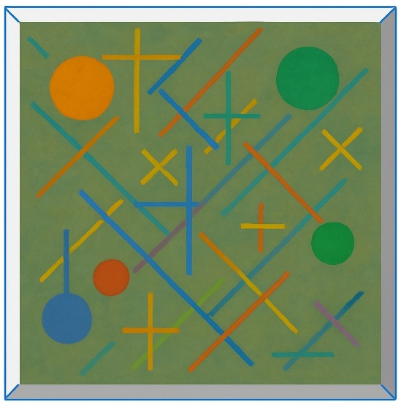
Paddington became friends with a man named Mr. Gruber. Mr. Gruber owned a shop, and Paddington liked it because the shelves were low, so he didn’t have to stand on tiptoe to see the things.

Mr. Gruber was usually outside the shop, and Paddington enjoyed talking with him and eating bread and drinking cocoa together.

Paddington became interested in the value of money. When he asked Mr. Gruber about it, he learned an important lesson: things are not always what they seem. For example, in the past, some artists didn’t have enough money to buy new canvases, so they painted over old paintings. That means there might be a valuable painting hidden under a worthless one.

After hearing this, Paddington thought there might be a valuable painting under a picture in his house. He tried hard to remove the top painting, but there was nothing underneath, so he painted a new picture there himself. The Brown family didn’t notice what he had done, and Paddington didn’t know that the picture had been painted by Mr. Brown for an art contest the next day.

The next day, Mr. Brown’s picture won a prize in the contest. But he was confused because it wasn’t the picture he had painted. Then he saw Paddington in the audience and understood what had happened.

In the end, Mr. Brown decided to donate the prize money to a certain home for retired bears.

